**Ganpat University**

**Faculty of Engineering & Technology**

**Computer Science & Engineering**

**(2CSE204) Basics of Operating System and Shell Scripting**

***Name:- Dwij Vatsal Desai***

***Sem:- 2***

***Sub: - BOSS***

***Enrollment No.:- 23162121027***

***Prac:- 5***

***Date:- 27/3/2024***

**Practical 5**

**Create the following users, groups and group members:**

1. User ‘Virat’, ‘Rohit’ and ‘Shubman’ and Group ‘cricket’.

***Command:-***

sudo groupadd Cricket

sudo useradd -m -G Cricket Virat

sudo useradd -m -G Cricket Rohit

sudo useradd -m -G Cricket Shubman

***Screenshot:-***

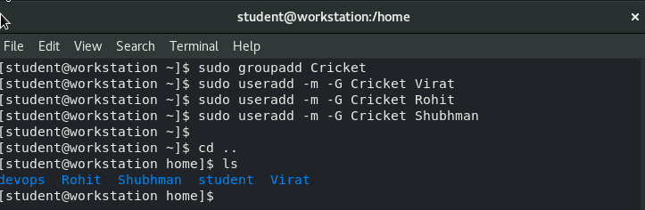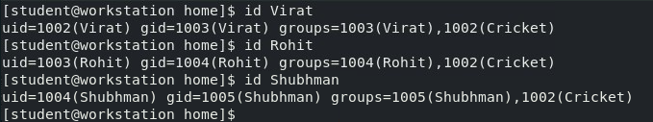

1. The user ‘Virat’ belongs to the ‘IPL’ group as a secondary group

***Command:-***

sudo groupadd IPL

sudo usermod -aG IPL Virat

***Screenshot:-***

. 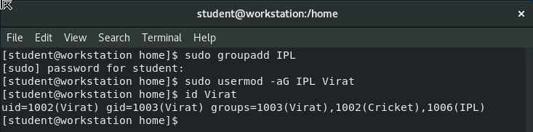

1. For User ‘Rohit’, ‘cricket’ group should be primary and ‘IPL’ should be secondary.

***Command:-***

sudo usermod -g cricket -aG IPL Rohit

***Screenshot:-***

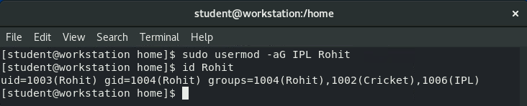

1. ‘Virat’, ‘Rohit’, and ‘Shubman’ should have password “batsman”

***Command:-***

sudo passwd Virat

sudo passwd Rohit

sudo passwd Shubman

password:- batsman

***Screenshot:-***

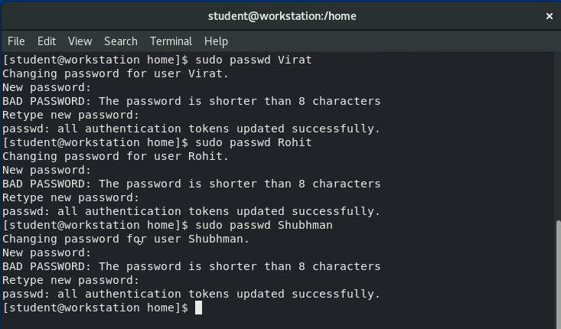

1. User ‘Shubman’ who does not have access to interactive shell on the system and who is also a member of ‘IPL’ group.

***Command:-***

sudo useradd -M -s /sbin/nologin -G IPL shubman

***Screenshot:-***

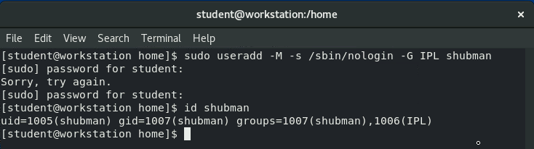

**Create the following users, groups and group members:**

1. A group named adminuser with groupid 1020.

***Command:-***

sudo groupadd -g 1020 adminuser

getent group adminuser

**Screenshot:-**

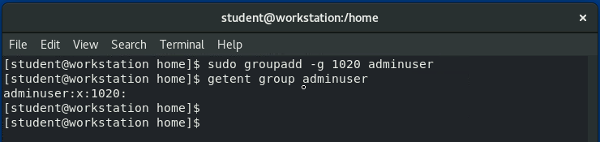

1. A user named woody, which belongs to the adminuser, this group is the user's primary group

***Command:-***

sudo useradd -g adminuser woody

id woody

***Screenshot:-***

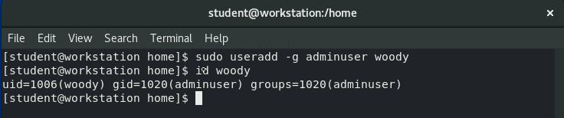

1. A user named buzz, belonging to the adminuser, is a supplementary group for the user

***Command:-***

sudo useradd -G adminuser buzz

id buzz

***Screenshot:-***

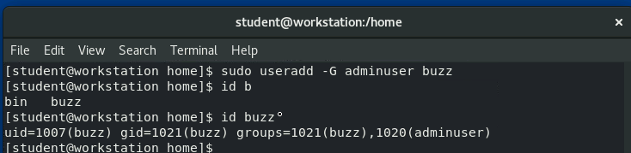

1. Users woody, buzz, and sid, the password should be set to “password321”

***Command:-***

sudo passwd woody

sudo passwd buzz

sudo useradd -g adminuser sid

sudo passwd sid

password:- password321

***Screenshot:-***

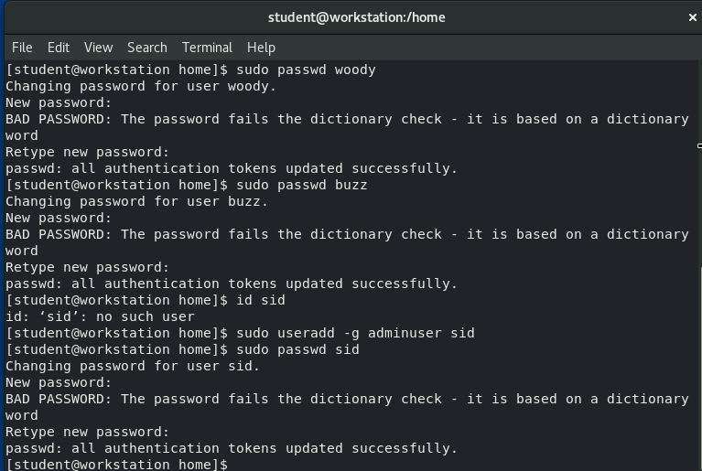

1. A user named sid, which has no interactive shell in the system and is not a member of the admin user group

***Command:-***

Sudo userdel -r sid

sudo useradd -M -s /sbin/nologin sid

***Screenshot:-***

